
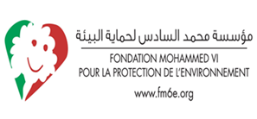
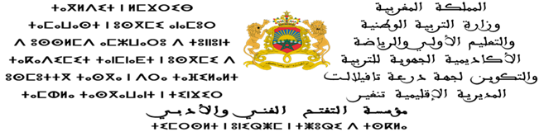

Traditional sewage wells in the outskirts of Tinghir: a solution or a problem?
Hanane Boussata and Mohamed Ahbar
Trainer: Meftah Rachid
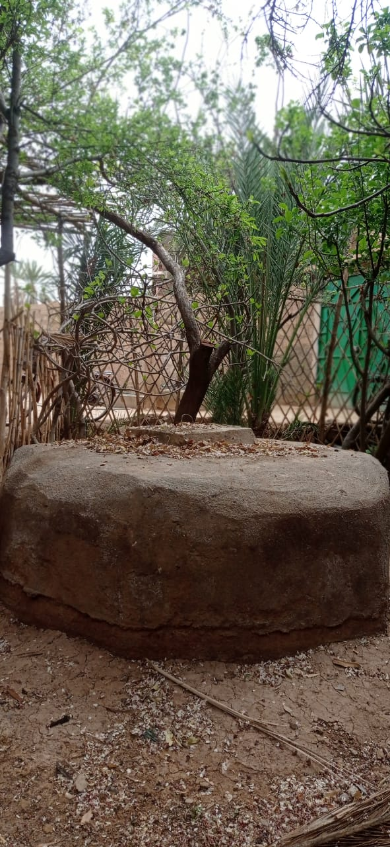
Prior to the provision of sanitation to the city of Tinghir and its villages, people relied on traditional methods such as digging sewage wells. These were abandoned as soon as a sewage system was installed in the city center, but the villages in the outskirt are still using these wells as their only alternative to the sewage network, which has not yet reached them. So, how did these wells become a problem, instead of a solution, and what challenges do the people who use them face ?
Image 1: A sewage well in one of the houses in Harate El Yamine village in the outskirts of Tinghir.
Tinghir is a city in southeast Morocco. As it began to be supplied with sewage channels, the traditional ways of disposing of wastewater were abandoned. But the residents of nearby villages still maintain these traditional alternatives because of the absence of a sanitation network. One of these alternatives is to dig sewage wells inside or outside houses. Despite this alternative, the inhabitants have been calling the authorities to connect their villages to the sewage network, but in vain. With the passage of years and no other solution available, the inhabitants find themselves forced to dig other more advanced wells to be able to empty them when they are full. Zinba, a resident of Harate El Yamine village, said: "For years, we have been waiting, and the sewage system hasn't reached everyone yet! Everyone has to dig a well in their house, and in many cases this waste seeps into groundwater, but there's no solution". This testimony is one of a hundred among the inhabitants, who are very aware of the damage caused by these wells.
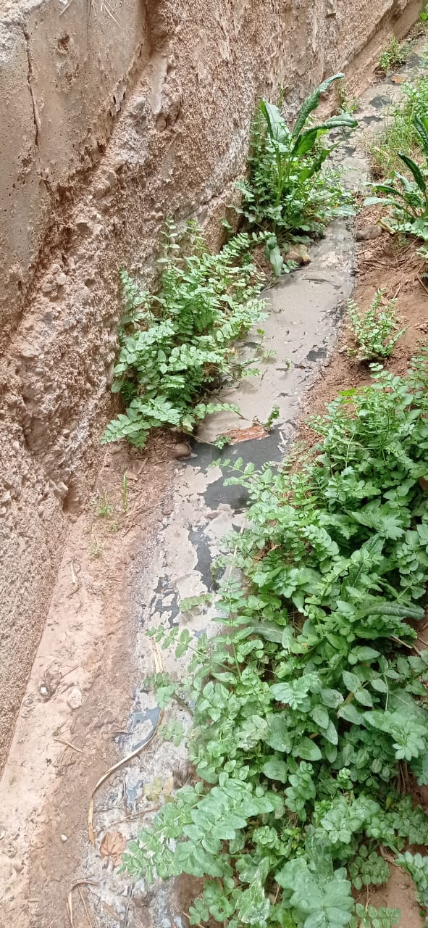
To avoid the rapid filling of these wells, many people still get rid of wastewater from kitchens and washing machines by dumping it into fields and streets. As a result, we find valleys of murky water on the roads and streets, and the crops and trees are damaged. Moreover, this wastewater invites insects and causes Leishmaniasis. One of the mothers in these areas expressed her suffering with these insects us. Her son was exposed to their stings and despite receiving treatment, the effects remained on his body. In addition, unpleasant odours emerge when trying to empty these wells after they are full. According to WHO, water pollution and poor sanitation services are associated with the transmission of diseases such as cholera, diarrhea, hepatitis A and many other diseases.
All these problems are well known to the inhabitants, but there is no other solution. Drilling these wells is much better than disposing of wastewater in rivers and fields, thus causing much bigger problems. Therefore, sewage wells are a short-term solution, but may lead to long-term negative effects. The only solution remains the intervention of the relevant authorities in order to provide the people with sewage canals and to save them from diseases. This bad situation is never ordinary and must never be overlooked! It threatens the lives of individuals, and we must address it appropriately in order to guarantee their rights as explained in the UN Sustainable Development Goals.
Image 2: kitchen and washing machine wastewater which is dumped into the fields
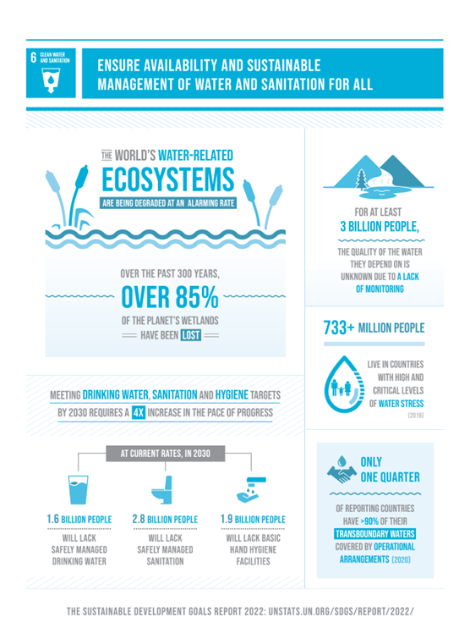
Goal 6 Clean water and sanitation: We must ensure availability and sustainable management of water and sanitation for all, protect individuals, and provide clean water resources for them.
Goal 13 Climate action: We must take urgent action to combat climate change and its impacts, and that is how we will keep our planet safe.
We talk a lot about the level of development that we have reached in recent decades, but as shown in the infographic, there are billions of people who do not yet have or will lack access to sanitation. This must be our priority in order to enable them to access these services. It is the responsibility of all of us.
Sources:
https://tinghir.info/
https://sdgs.un.org/goals
https://www.who.int/ar/news-room/fact-sheets/detail/drinking-water

Testimony of a woman from Tinghir (translated from Tamazight into English by Hanane Boussata)
Infographic: https://sdgs.un.org/goals/goal6

